**Academic Counseling installation Guide**

Required programs to run the project

1. [.NET SDK and Runtime](https://dotnet.microsoft.com/en-us/download/dotnet/6.0)
2. [Visual Studio 2022](https://visualstudio.microsoft.com/thank-you-downloading-visual-studio/?sku=Community&channel=Release&version=VS2022&source=VSLandingPage&cid=2030&passive=false)
3. [SQL Server 2019](https://www.microsoft.com/en-us/sql-server/sql-server-downloads)
4. [SQL Server Management Studio](https://go.microsoft.com/fwlink/?linkid=2203303&clcid=0x409)
5.** 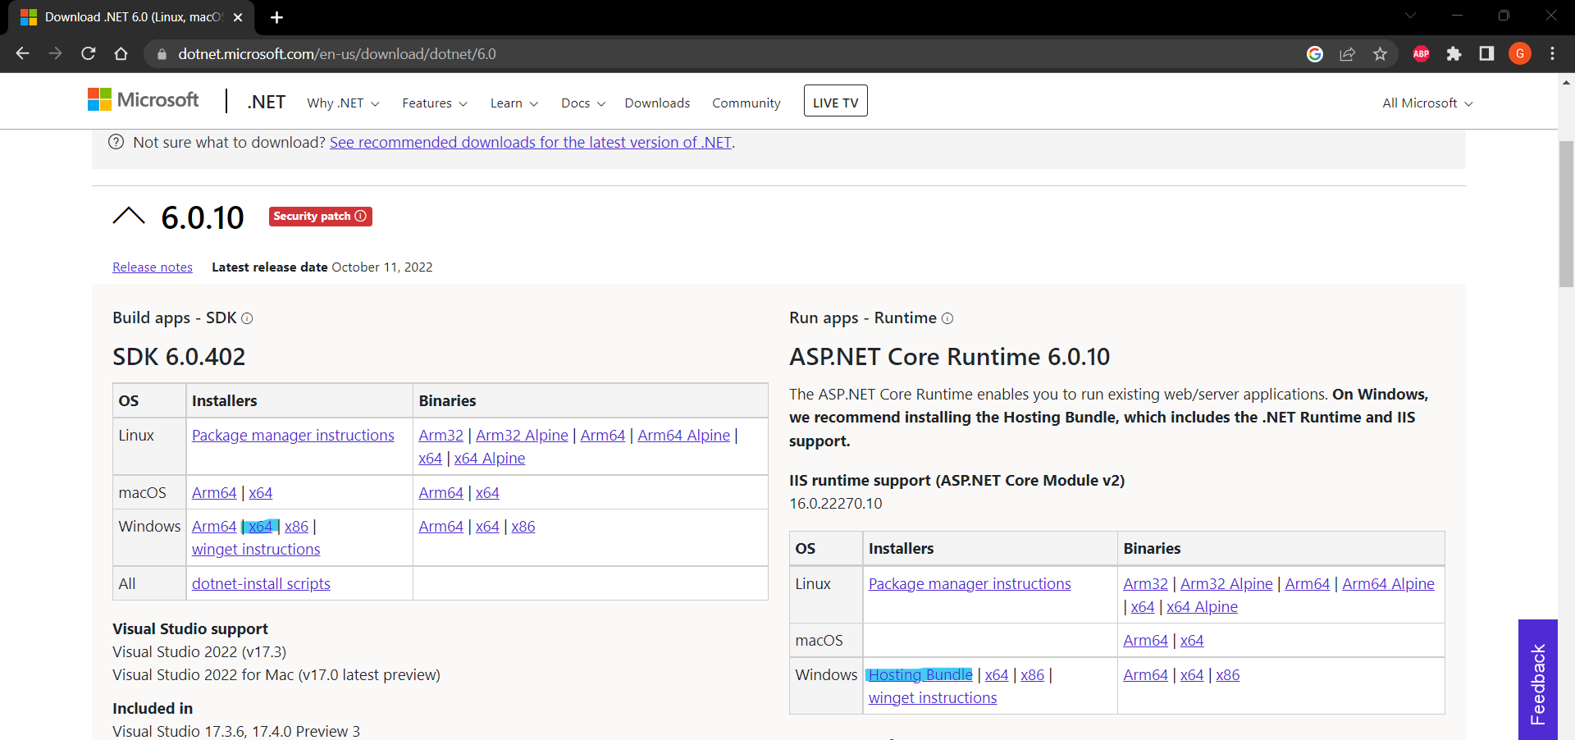.NET SDK and Runtime**

Download highlighted packages, install them, then restart your PC

1. **VS 2022**

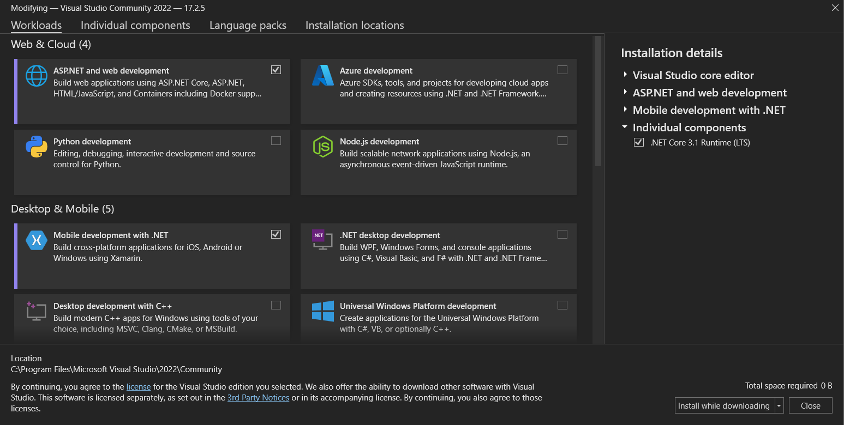

Select “ASP.NET and web development” and continue installing.

1. 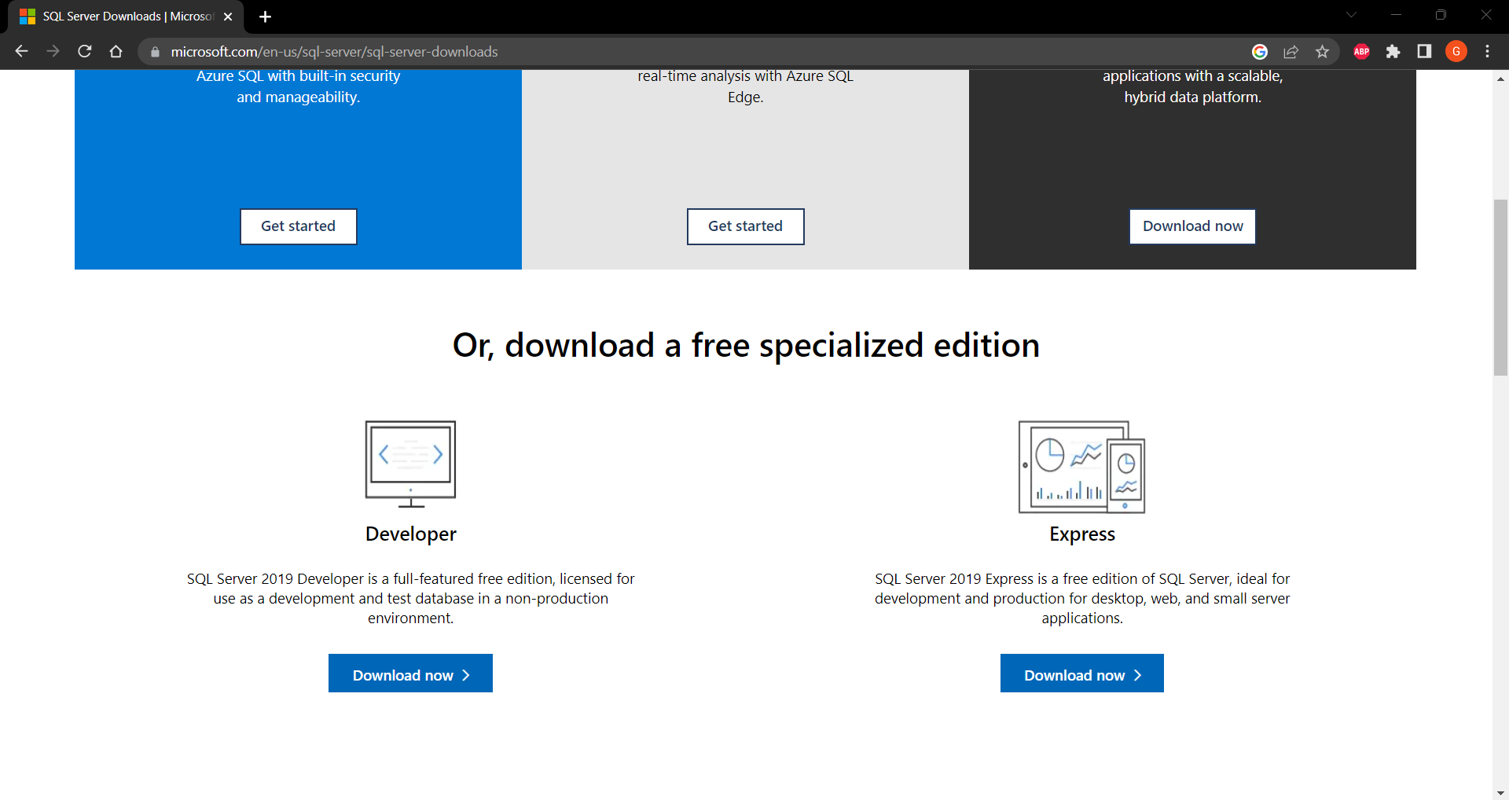**SQL Server 2019**

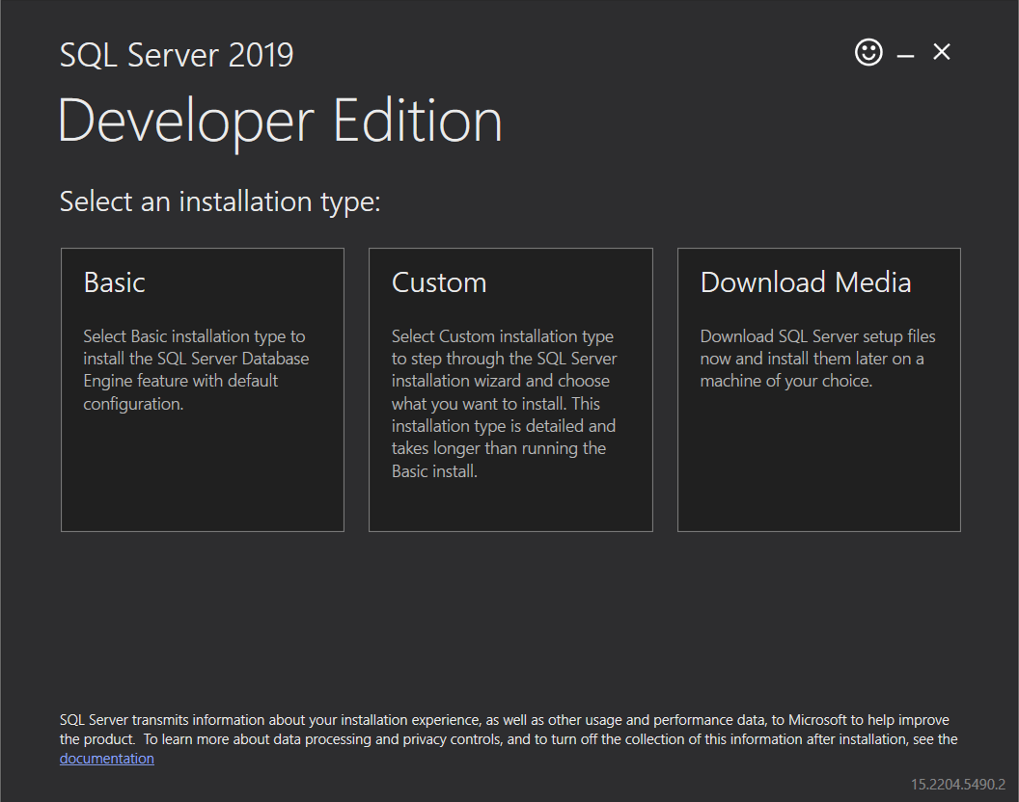Download Developer Version

Select Basic and continue installing

1. **SQL Server Management Studio** to custom settings to ser, just install it

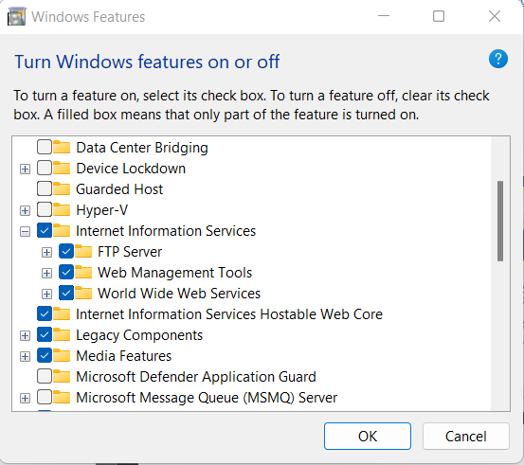After installing mentioned programs,

Open Start and search for

**windows features**

you need to check

1. Internet Information Services (IIS) Manager and everything inside it
2. Internet Information Services Hostable Web Core

Then press OK

Now download application from [GitHub](https://github.com/Girguis/Academic-Counseling) Repo, open it in VS 2022

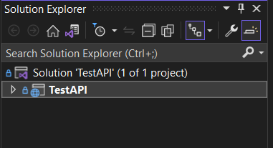

Right click on TestAPI

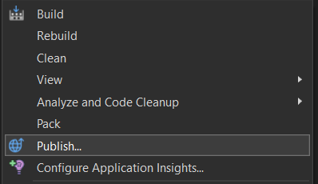

Click on Publish

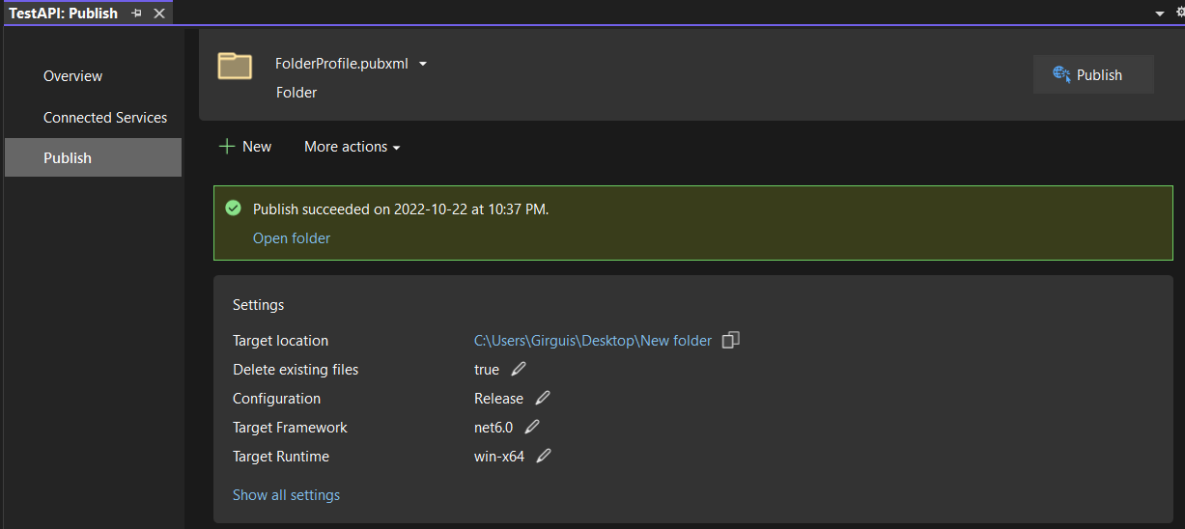

Click Show all settings

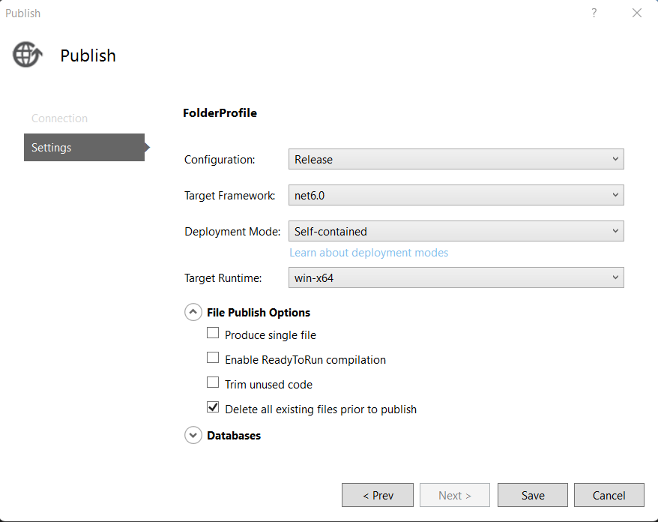

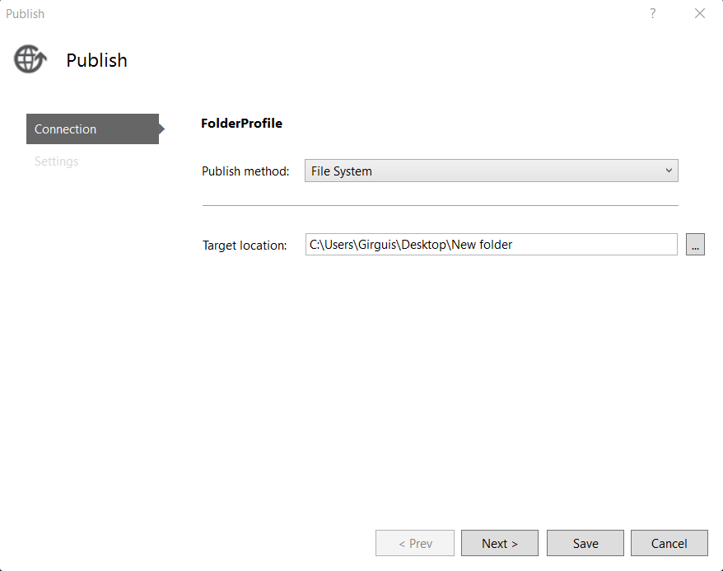

Do the same as shown in the images

Click save, then click publish

When publish is completed copy files to this directory C:\inetpub\wwwroot\Academic Counseling

Now run IIS and follow the following pictures

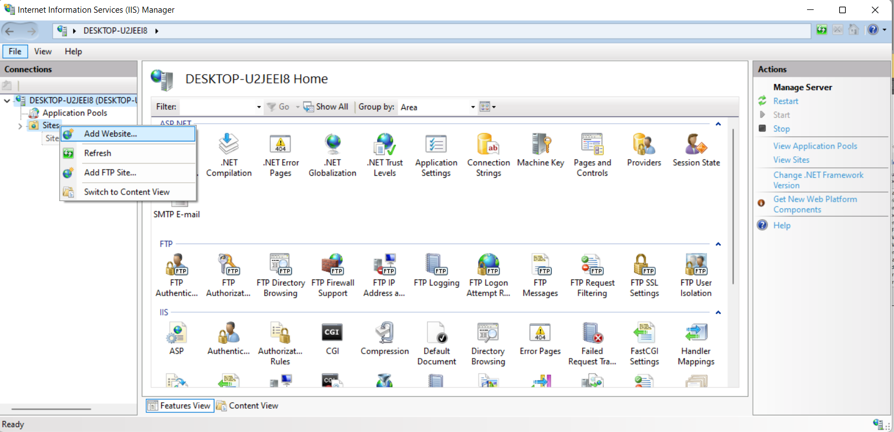

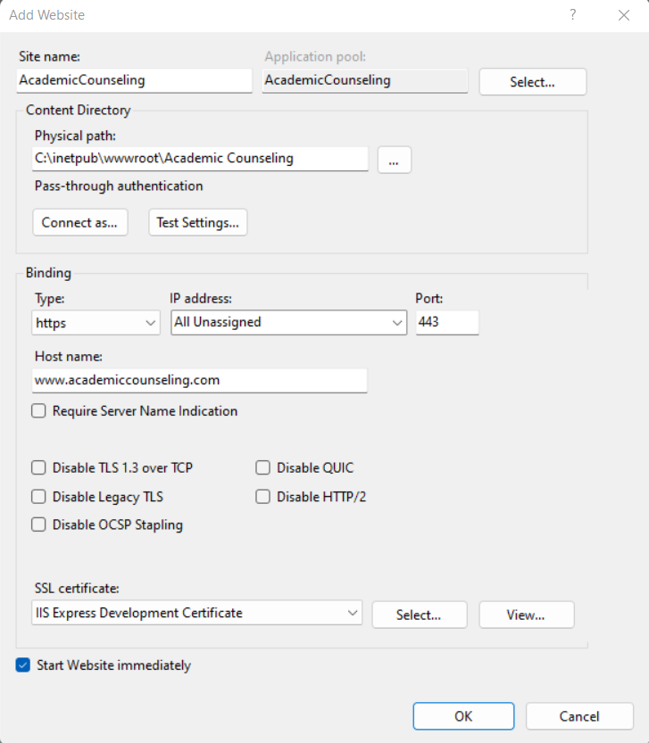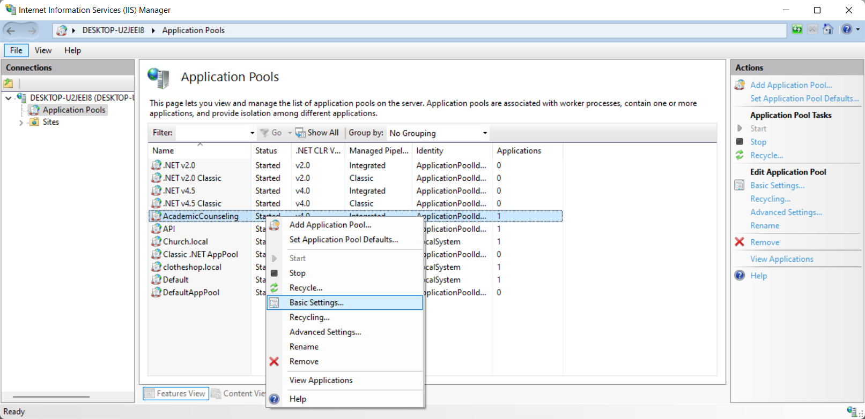

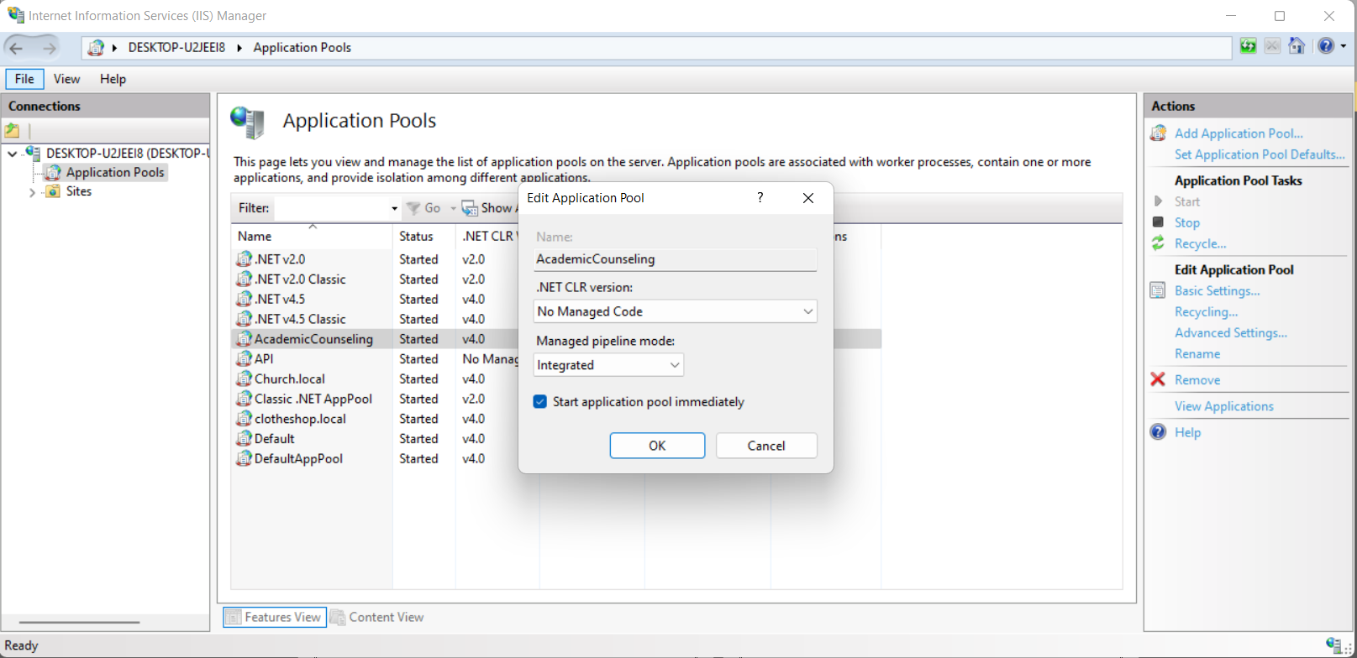

Open this directory

C:\Windows\System32\drivers\etc

Open hosts file

Add this line to the end of the file

127.0.0.1 www.academiccounseling.com

Save and close the file, now go back to IIS

To open the website

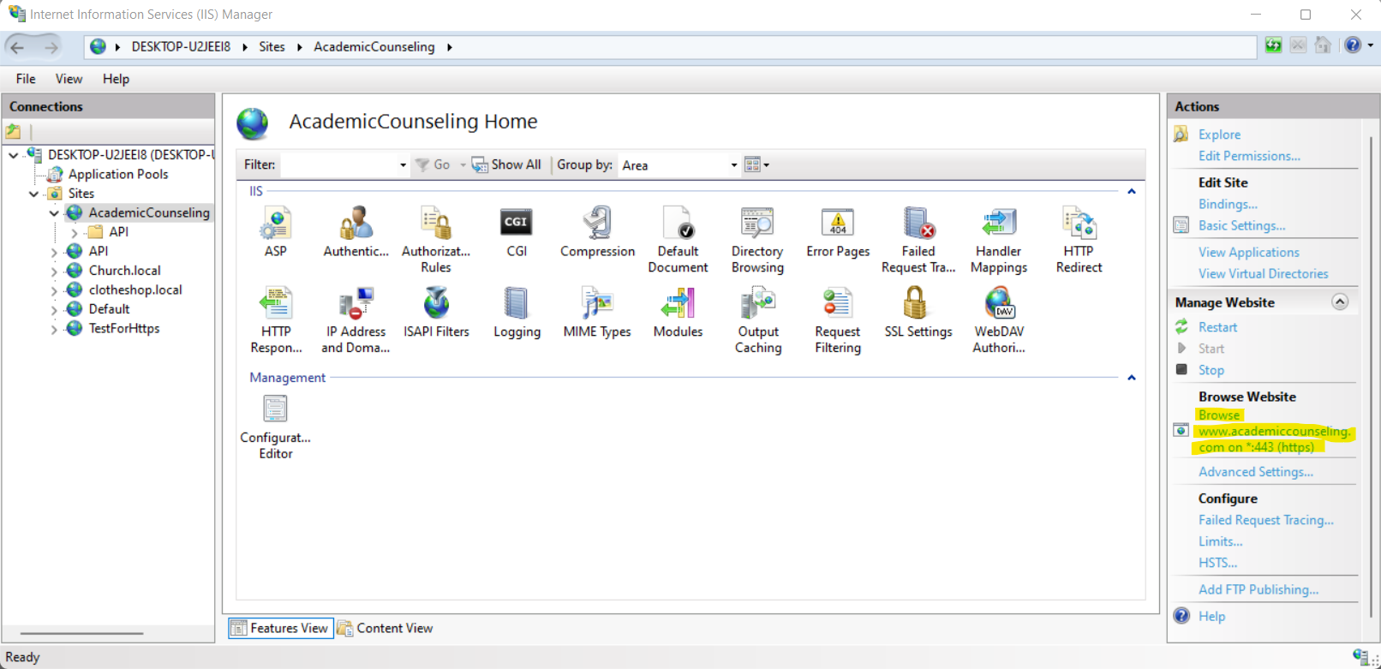

Click on “Browse www.academiccounseling.com on * :443 (https)”

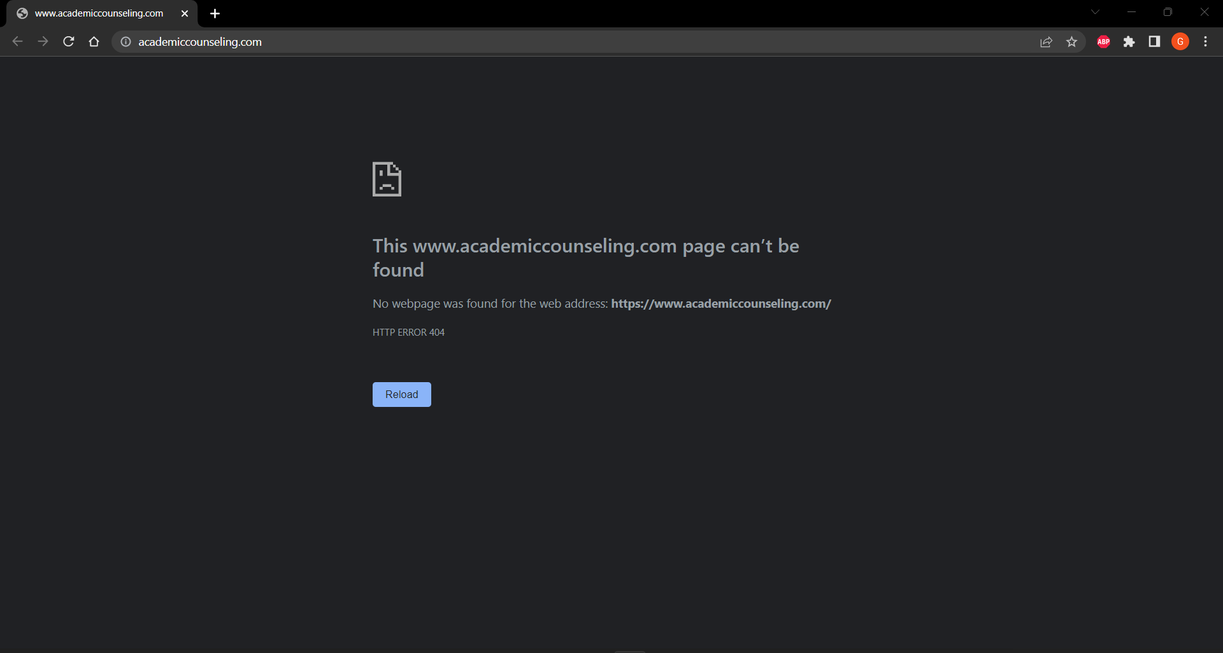

Now all what you need to do is to call the API you want

